Lab Week 3 Sample Solutions

Q1 Prepare System sequence diagrams for the Use case “professor submits grades”

**Sample Solution**

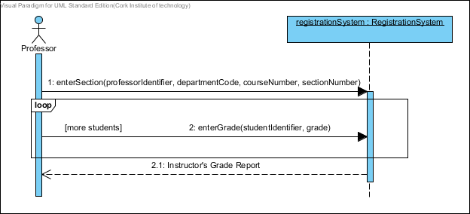

Q2 Consider an Event table for a library system . Make appropriate assumptions to limit the scope of the system. Some suggestions are suggested below.

Focus on events related to the circulation of books. Ignore the acquisition and disposal of lendable items.

**Sample Solution**

|  |  |  |  |  |  |
| --- | --- | --- | --- | --- | --- |
|  | **Event Description** | **System Input** | **Actor Providing Input** | **System Output** | **Actor  Receiving  Output** |
| 1. | Patron requests library membership | Membership Request | Patron | Membership | Patron |
| 2. | Patron borrows book | Loan Request | Patron | Loan Receipt | Patron |
| 3. | Patron returns book | Return Request | Patron | Return Receipt | Patron |
| 4. | Patron pays fine | Payment | Patron | Fine Receipt | Patron |
| 5. | Time to send overdue book notice |  |  | Overdue Book Notice | Patron |

Q3 Draw a Domain model for the use case Check out Library book shown in figures below

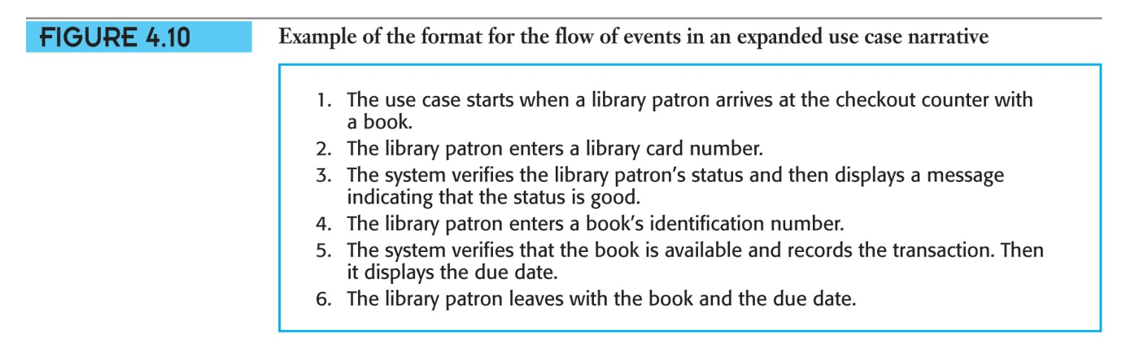

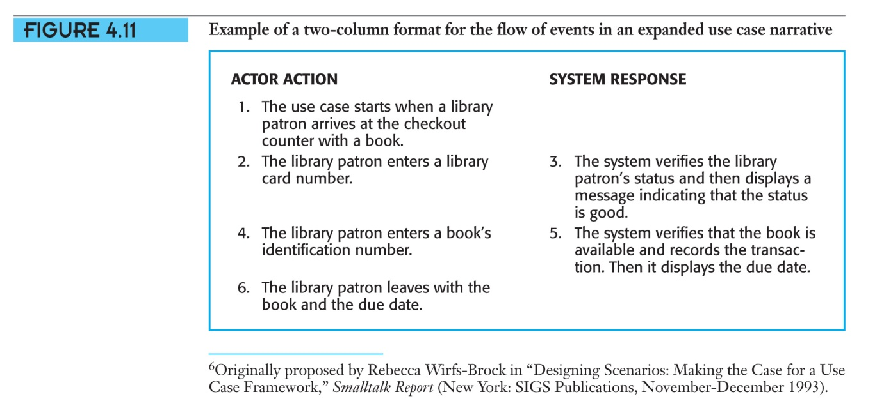

**Sample Solution**

Q4 Modify the domain model for the Public University Registration System to accommodate the new events identified in lab 2

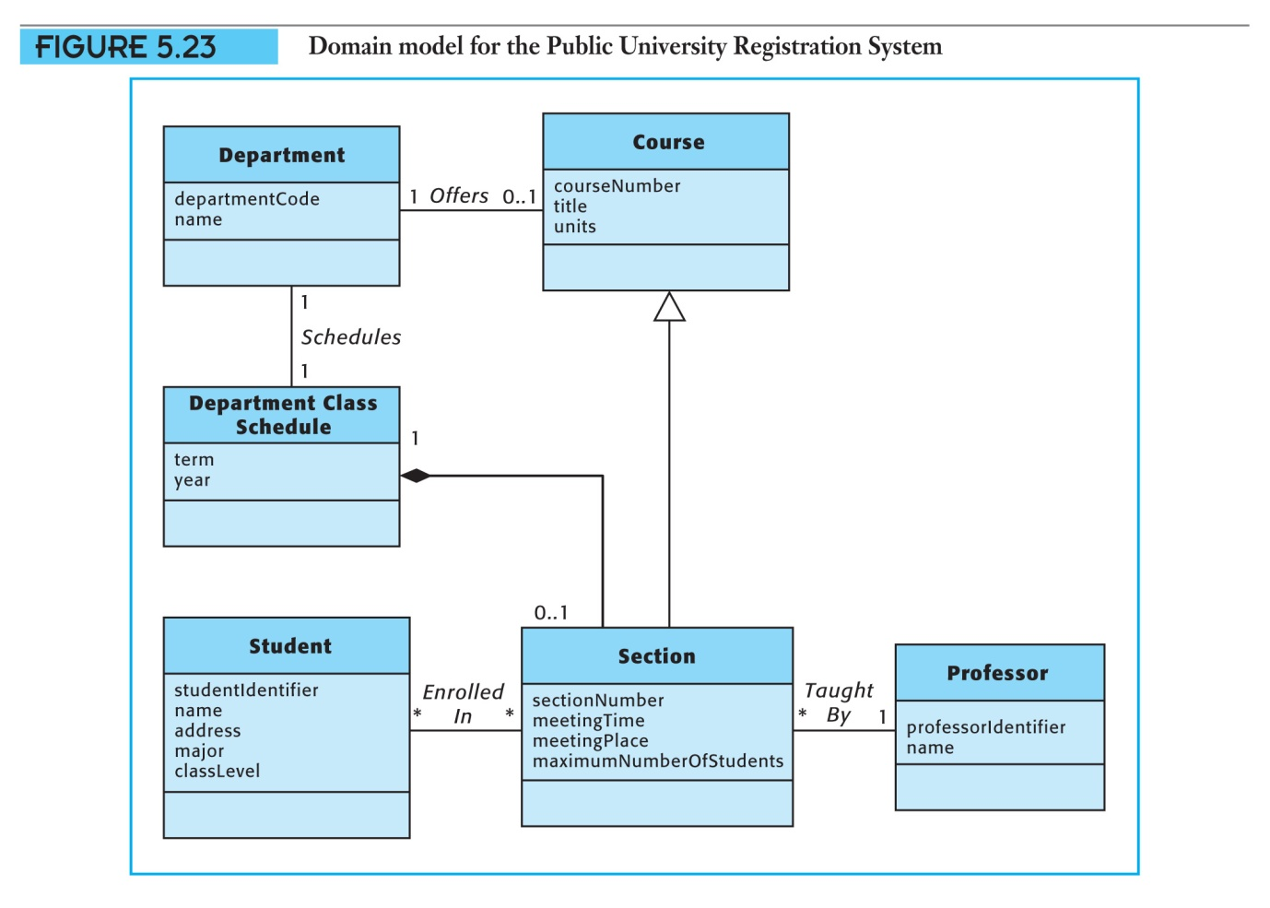

**Sample Solution**



Q5 Write a system operation contract for each of the operations shown in system sequence diagram **Check out library Book**

**Contract for the *enterCardNumber* system operation**

|  |  |
| --- | --- |
| **Use Case:** | **Check Out Book** |
| **Contract Name:** | **enterCardNumber(cardNumber)** |
| **Responsibilities:** | Record the Patron who is checking out this book. |
| **Type:** | System |
| **Exceptions:** | If the member number is not valid, indicate that it was an error. |
| **Output:** | None |
| **Preconditions:** | Patron is known to the system. |
| **Postconditions:** | A new instance of Checkout Transaction was created. The Checkout Transaction was associated with the Patron. |

**Contract for the *enterBookIdentifier***

|  |  |
| --- | --- |
| **Use Case:** | **Check Out Book** |
| **Contract Name:** | **enterBookIdentifier(bookIdentifier)** |
| **Responsibilities:** | Record the book being checked out. |
| **Type:** | System |
| **Exceptions:** | If the bookIdentifier is not valid, indicate that it was an error. |
| **Output:** | None |
| **Preconditions:** | Book is known to the system. |
| **Postconditions:** | A new instance of Checkout Item was created. The Checkout Item was associated with the Checkout transaction and with the Book Copy.  A Checkout Receipt was produced. |